# Task 3

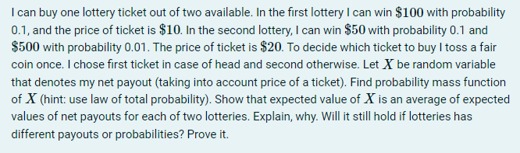

Let L1 and L2 be random variables that denote net payouts of the 1st and 2nd lotteries correspondingly.

|  |  |  |
| --- | --- | --- |
| L1 | 90 | 0 |
| P | 0.1 | 0.9 |

|  |  |  |  |
| --- | --- | --- | --- |
| L2 | 480 | 30 | -20 |
| P | 0.01 | 0.1 | 0.89 |

$$EL_{2}=480⋅0.01+30⋅0.1-20⋅0.89=-10$$

Probability mass function of X:

|  |  |  |  |  |  |
| --- | --- | --- | --- | --- | --- |
| X | 480 | 90 | 30 | 0 | -20 |
| P | 0.005 | 0.05 | 0.05 | 0.45 | 0.445 |

$$EX=480⋅0.005+90⋅0.05+30⋅0.05+0⋅0.45-20⋅0.445=-0.5$$

$$\frac{EL_{1}+EL_{2}}{2}=\frac{9-10}{2}=-0.5$$

Hence, $EX=\frac{EL_{1}+EL_{2}}{2}$.

This can be explained by law of total probability and illustrated by following probability trees:

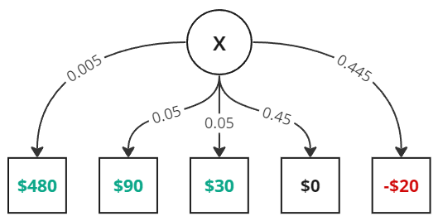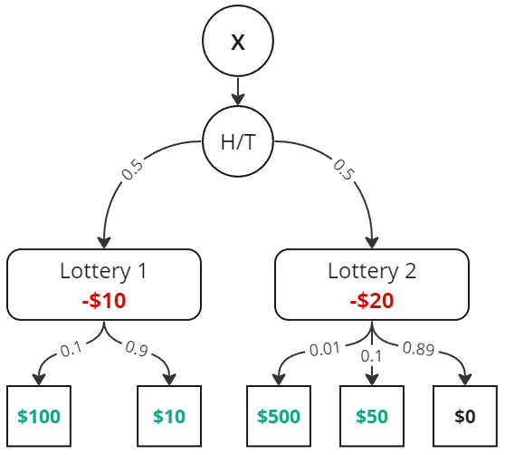

Now let’s prove, that $EX=\frac{1}{2}\left(EL_{1}+EL_{2}\right)$ for any probabilities and payouts in the lotteries.

Let $L_{1}$ take values $a_{1},a_{2},…, a_{k}$ with corresponding probabilities $p_{1},p_{2},…,p_{k}$ and $L_{2}$ take values $b_{1},b_{2},…, b_{n}$ with corresponding probabilities $q_{1},q_{2},…,q_{n}$.

Then their expected values are:

$EL_{1}=a_{1}⋅p_{1}+a_{2}⋅p_{2}+…+a_{k}⋅p_{k}$,

$EL_{2}=b_{1}⋅q_{1}+b_{2}⋅q_{2}+…+b_{n}⋅q_{n}$.

By the law of total probability variable $X$ can have values $a_{1},a_{2},…, a_{k}, b_{1},b_{2},…, b_{n}$ with corresponding probabilities $\frac{p_{1}}{2},\frac{p_{2}}{2},…,\frac{p_{k}}{2},\frac{q_{1}}{2},\frac{q_{2}}{2},…,\frac{q_{n}}{2}$.

Then we can calculate it’s expected value:

$EX=a_{1}⋅\frac{p_{1}}{2}+a_{2}⋅\frac{p_{2}}{2}+…+a_{k}⋅\frac{p_{k}}{2}+b_{1}⋅\frac{q_{1}}{2}+b_{2}⋅\frac{q_{2}}{2}+…+b_{n}⋅\frac{q_{n}}{2}$.

We can group up some of the terms:

$$EX=\frac{1}{2}⋅\left(a_{1}⋅p_{1}+a_{2}⋅p_{2}+…+a_{k}⋅p_{k}\right)+\frac{1}{2}\left(b_{1}⋅q_{1}+b_{2}⋅q_{2}+…+b_{n}⋅q_{n}\right)=$$

$=\frac{1}{2}EL_{1}+\frac{1}{2}EL_{2}=\frac{1}{2}\left(EL_{1}+EL_{2}\right)$, q.e.d.